Software Quality Assurance (SQA) – 4th Week Project Task
Name: Dariya Hashmi -- DHC (2403)
Project Title: Performance & Load Testing Test Plan

Objective:
The objective of this test plan is to design a performance test for The Internet demo site (https://the-internet.herokuapp.com) focusing on login and logout functionality. This plan ensures all necessary steps, configurations, and parameters are defined before execution.

Test Environment
- System: Windows 10, 8GB RAM, Intel i5
- JMeter Version: 5.6.3
- Browser: Chrome 146.0
- Website Tested: The Internet Demo Site

Test Plan Setup
Thread Group:
- Users (Threads): 5
- Ramp-Up Period: 5 seconds
- Loop Count: 1
Samplers:
- Login Request → POST /authenticate (username=tomsmith, password=SuperSecretPassword!)
- Logout Request → GET /logout
Config Element:
- HTTP Cookie Manager → Automatic session handling
Listeners:
- View Results Tree
- Graph Results
- Summary Report

Test Steps
- Open JMeter → New Test Plan
- Add Thread Group → Configure users, ramp-up, loop count
- Add HTTP Cookie Manager
- Add Login and Logout requests
- Add Listeners
- Save Test Plan → Ready to execute

Expected Results
- Login and Logout requests should succeed
- No errors during execution
- System ready for performance measurement

Screenshots
Fig 1: Thread Group Setup
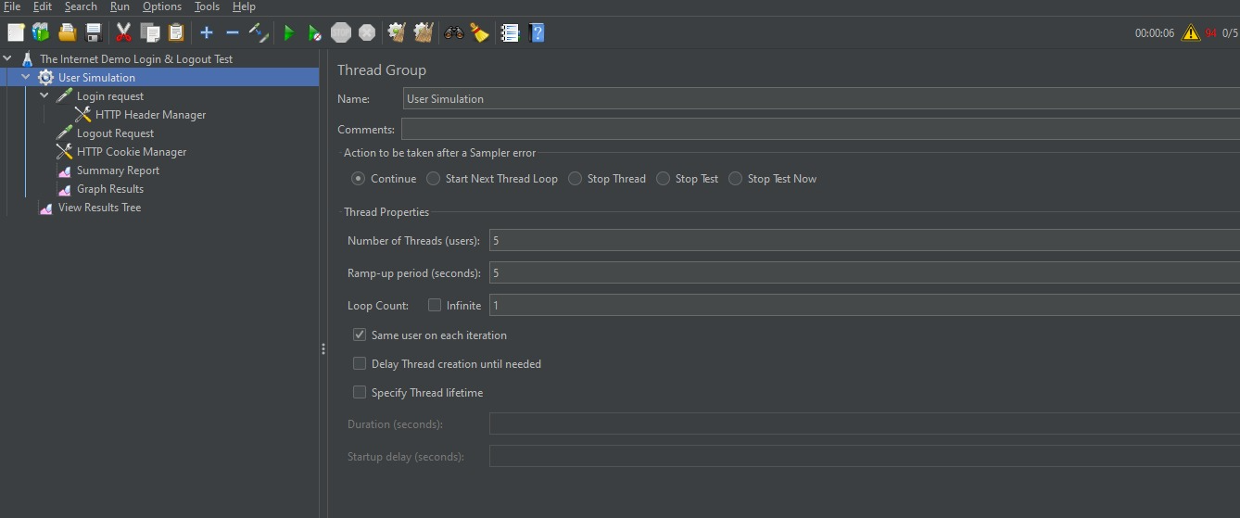

Fig 2: HTTP Samplers – Login & Logout
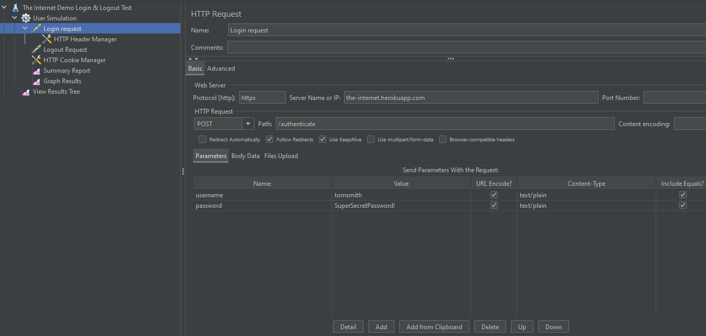
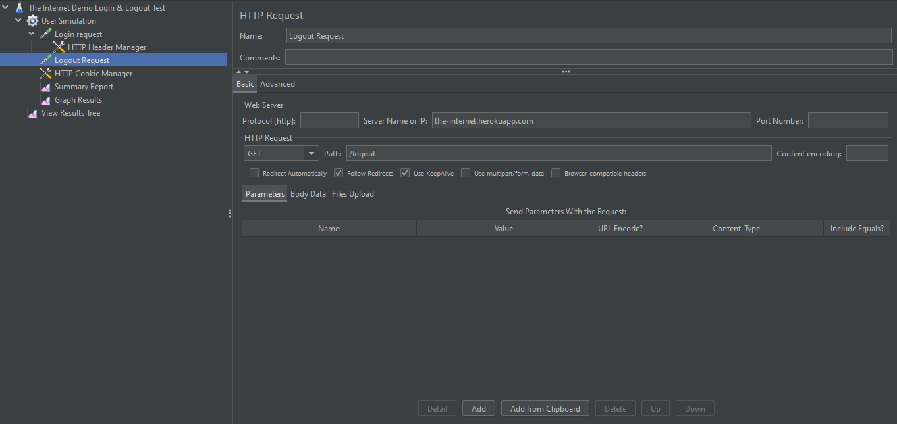
Fig 3: HTTP Cookie Manager
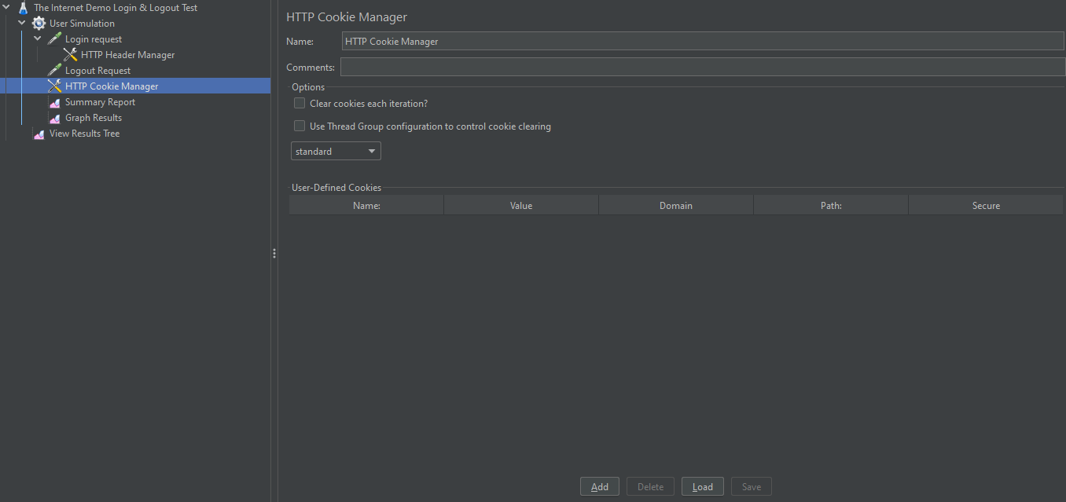

Fig 4: Listeners Setup
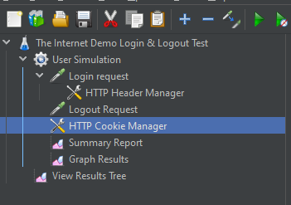

Github Repository :
https://github.com/dariyahashmi2602-source/SQA_Week4_Test-plan-Doc-

